Mission 2: CodeBot Assignment | Name:
Label the parts of the CodeBot.
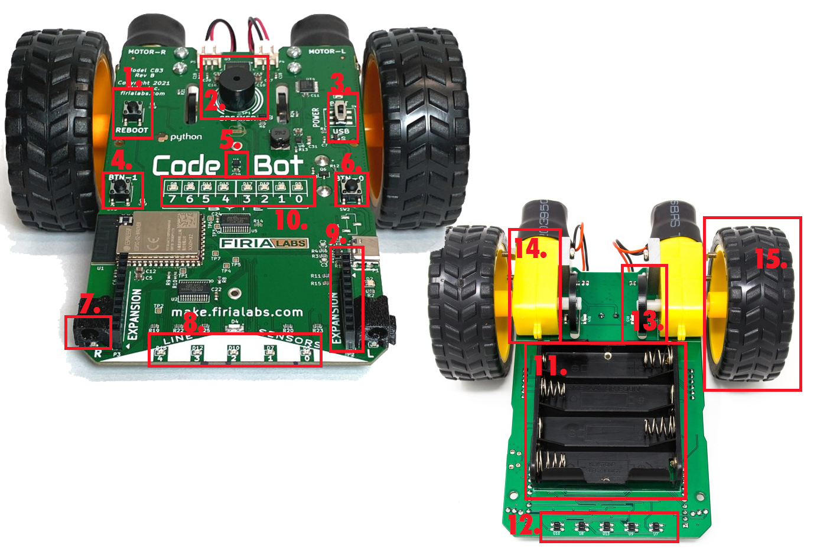
1. | 9.
2. | 10.
3. | 11.
4. | 12.
5. | 13.
6. | 14.
7. | 15.
8.

Parts of CodeBot:
- Accelerometer
- Expansion connector
- Battery pack
- User LEDs
- Wheel encoders
- Line sensor LEDs
- Line sensors
- Button 0
- Button 1
- Wheels
- Proximity sensors
- Reboot button
- Speaker
- Motors
- Power switch

